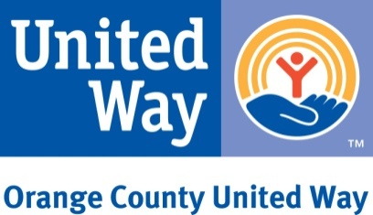

MARTIN LUTHER KING DAY OF VOLUNTEERING
VOLUNTEER OPPORTUNITY
JANUARY 17, 2014

DESCRIPTION
Orange County United Way is seeking volunteers to support its 2013/14 Free Tax Prep campaign. The Free Tax Prep campaign provides free tax preparation services to individuals, families and seniors earning less than $58,000. Tax returns are prepared by trained and IRS certified volunteers at various locations throughout Orange County. During the 2013 tax season, 13,771 households were served, bringing over $11 million back into the pockets of those who need it most. Nearly $3 million was returned from the Earned Income Tax Credit, an anti-poverty tool that can serve as the bridge out of poverty that many families need.

VOLUNTEER POSITIONS
Interpreter: Aids in translating information between the taxpayer and tax preparer. Spanish and Vietnamese interpreters are in high demand.
Greeter: Serves as first point of contact at events and directs taxpayers to the intake/interview room.
REQUIREMENTS
All volunteers are required to complete and pass the online Volunteer Standards of Conduct Training and Exam, which will be completed at the January 17th orientation session. Orange County United Way provides all the necessary materials and places volunteers (based on their respective preferences) with local partnering organizations during the tax season. Volunteers receive a Certificate of Appreciation from the IRS and the Franchise Tax Board at the end of the tax season. There are multiple sites and scheduling options including evenings and Saturdays.

Orientation will be held on January 17, 2014 at Orange County United Way, Training Room, located at 18012 Mitchell Avenue, South, Irvine, Ca 92614. Volunteers are required to complete only one of the two scheduled sessions:

Friday, January 17, 2014
10AM – 11:30AM

Friday, January 17, 2014
1:00PM – 2:30PM

CONTACT
For additional information or to register for an orientation session, please visit our volunteer webpage at http://vita.volunteerhub.com or contact Hoda Hessaramiri, Program Manager at hodah@unitedwayoc.org or 949.263.6167.

